**Showing Text on Trigger**

**(This shows how to pop up a text on trigger)**

1. **Create a Cube**

Game Object—3D Object—Cube—Rename to Message.

Reset the position of the game object (Message). Set position on Y axis 0.5 and on Z axis 5. Scale the X axis to 3.

1. **Create Text**

Game Object—UI—Text.

Edit Text on Text (Script).

Untick the box right next to Text/Right under Inspector.

1. **Tag the Player, Player**

Select Player from the Hierarchy—Tag – Add Tag—Press the Plus Button—Name the new tag Player—Select Player—Change the Tag from Untagged to Player.

1. **Create a Script**

Select The object (Message)—Add Component—New Script. Name Script PopUpText.

1. **The Script**

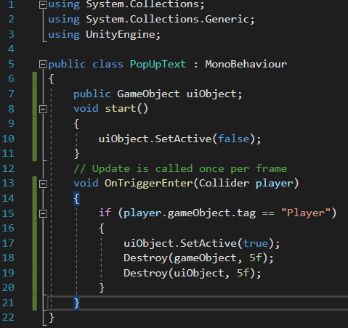

Line 7 Reference to Text.

Line 10 Unticks the Text.

Line 13 Reads the players collider.

Line 15 Reads the Tag of the player.

Line 17 Activates the Text.

Line 18,19 Destroys Game Object and UI Object.

1. **Add the Text on the Script.**

Select the Message from the Hierarchy and drag the Text into the Ui Object on the PopUpText Script.

Set Box Collider on Is Trigger.

Untick the Mesh Renderer.